Jolly Phonics
Click on the links below to hear the Jolly Jingle songs
In English, even though there are only 26 letters, there are actually 42 different sounds. This is because two or more letters together sometimes make just one sound, for example, “oa” as in goat and “ie” as in pie.
As seen in the lists below, Jolly Phonics teaches these 42 sounds in 7 different groups. Group 1 starts with the easiest sounds, and the sounds gradually get harder. Some sounds also have different ways of being written, for example, "ay” as in pay and “ai” as in paid. In Jolly Phonics, we call these “alternative spellings”.
At first, children are taught the most simple or common way of spelling each of the 42 sounds, as seen in the picture. Later, they are introduced to the alternative spellings.
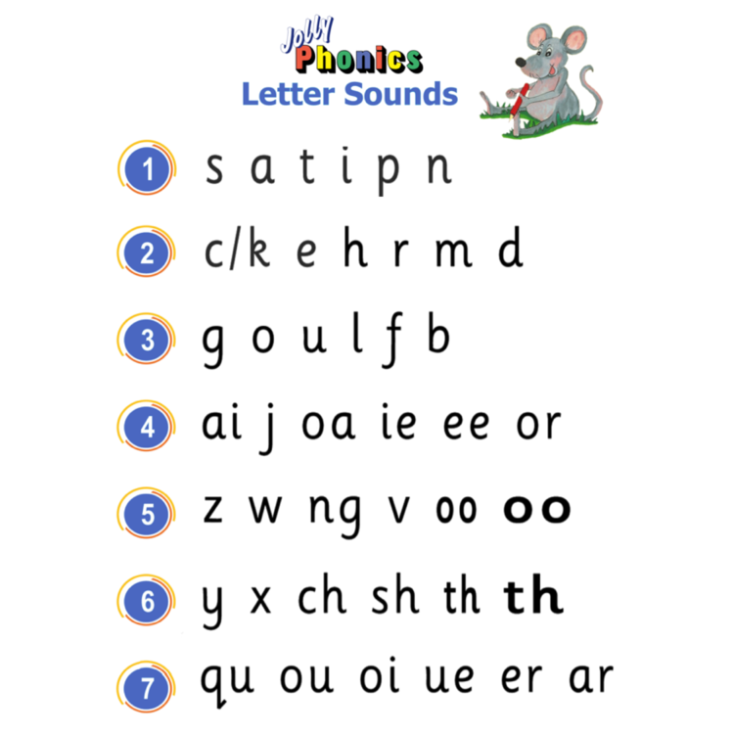

Jolly Jingles Part 1 - Bing video
Jolly Jingles Part 2 - Bing video
Jolly Jingles Part 3 - Bing video

